Central Angle
# Source: AI Source: Provided by: [Data Path: Persons Table -> ID Column: 1, Name_En Column: Motasem Essam] -> From: [ChatGPT] on [7/25/2026]
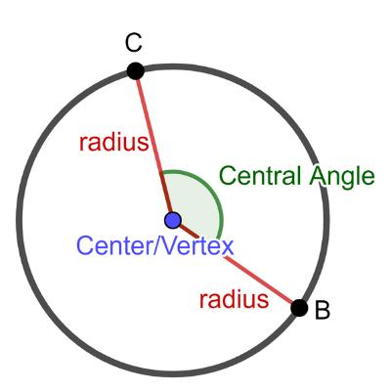
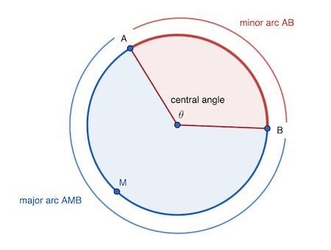
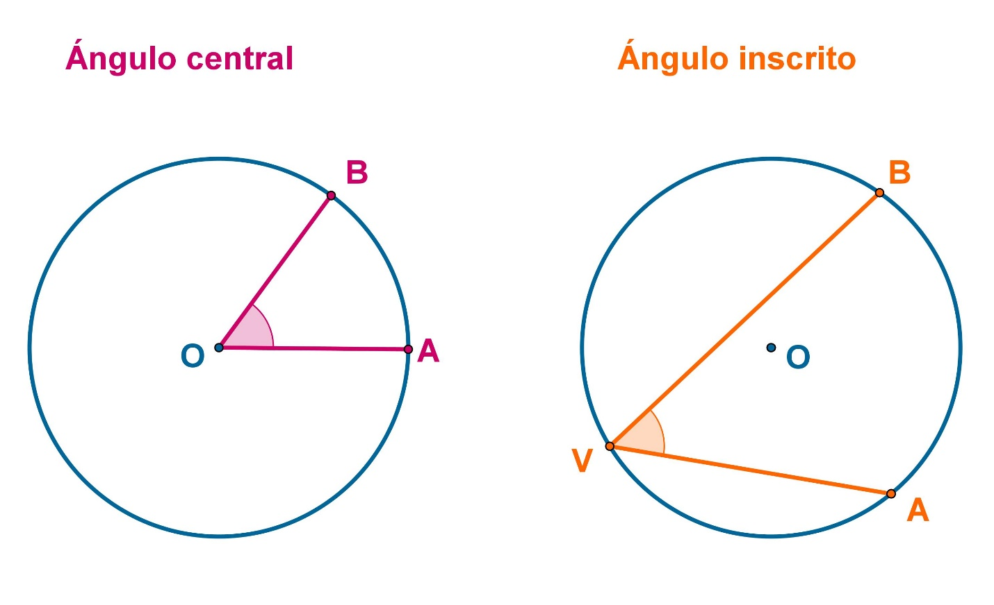
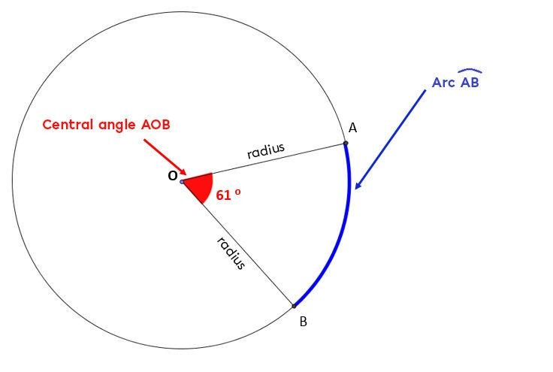
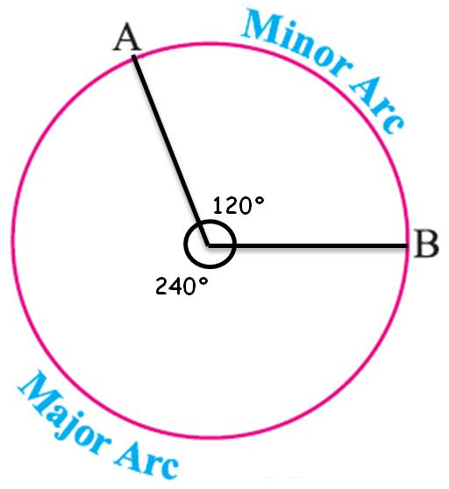
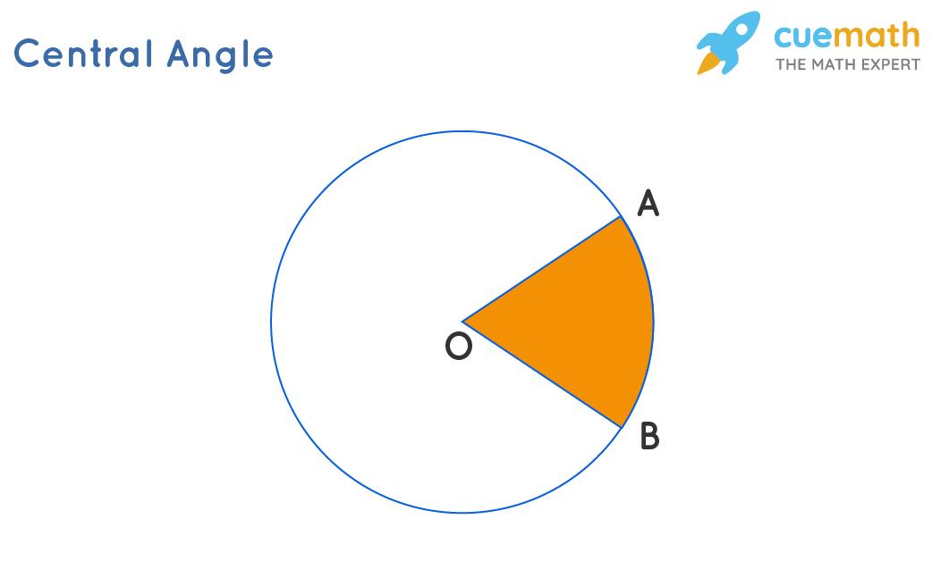

Definition
# Source: AI Source: Provided by: [Data Path: Persons Table -> ID Column: 1, Name_En Column: Motasem Essam] -> From: [ChatGPT] on [7/25/2026]
A Central Angle is an angle whose vertex is at the center of a circle and whose sides are radii of the circle.
For a circle with center $O$, if $A$and $B$lie on the circumference, then:
$$∠AOB$$
is a central angle.

Fundamental Concept
# Source: AI Source: Provided by: [Data Path: Persons Table -> ID Column: 1, Name_En Column: Motasem Essam] -> From: [ChatGPT] on [7/25/2026]
The central angle determines the measure of the arc intercepted by the angle.
$$\boxed{m\left(∠AOB\right)=m\left(\hat{AB}\right)}$$
when the angle and arc refer to the same minor or major portion.
For example:
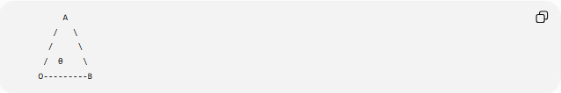
A
/ \
/ \
/ θ \
O---------B
- $O$= center
- $OA$and $OB$= radii
- $∠AOB$= central angle
- $\hat{AB}$= intercepted arc

Main Parts
# Source: AI Source: Provided by: [Data Path: Persons Table -> ID Column: 1, Name_En Column: Motasem Essam] -> From: [ChatGPT] on [7/25/2026]
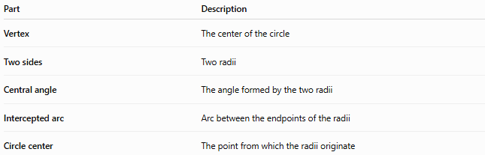
Part | Description
Vertex | The center of the circle
Two sides | Two radii
Central angle | The angle formed by the two radii
Intercepted arc | Arc between the endpoints of the radii
Circle center | The point from which the radii originate

Central Angle and Arc Measure
# Source: AI Source: Provided by: [Data Path: Persons Table -> ID Column: 1, Name_En Column: Motasem Essam] -> From: [ChatGPT] on [7/25/2026]
One of the most important properties is:
$$\boxed{m\left(∠AOB\right)=m\left(\hat{AB}\right)}$$
For example, if:
$$m\left(∠AOB\right)={70}^{∘}$$
then:
$$m\left(\hat{AB}\right)={70}^{∘}$$
Similarly, a ${120}^{∘}$central angle intercepts a ${120}^{∘}$arc.

Types of Central Angles
# Source: AI Source: Provided by: [Data Path: Persons Table -> ID Column: 1, Name_En Column: Motasem Essam] -> From: [ChatGPT] on [7/25/2026]
Central angles can be classified according to their measure:
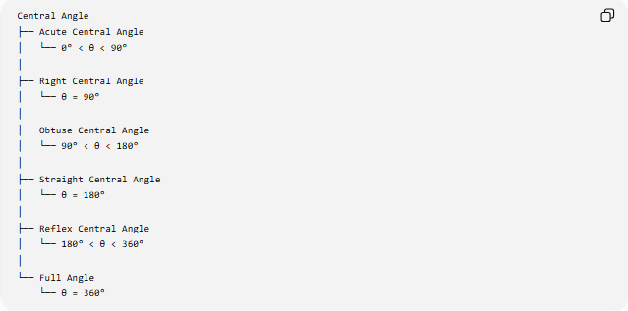
Central Angle
├── Acute Central Angle
│ └── 0° < θ < 90°
│
├── Right Central Angle
│ └── θ = 90°
│
├── Obtuse Central Angle
│ └── 90° < θ < 180°
│
├── Straight Central Angle
│ └── θ = 180°
│
├── Reflex Central Angle
│ └── 180° < θ < 360°
│
└── Full Angle
└── θ = 360°

Important
# Source: AI Source: Provided by: [Data Path: Persons Table -> ID Column: 1, Name_En Column: Motasem Essam] -> From: [ChatGPT] on [7/25/2026]
For circle geometry, central angles are particularly important because they correspond directly to arc measures.

Central Angle and Circle Parts
# Source: AI Source: Provided by: [Data Path: Persons Table -> ID Column: 1, Name_En Column: Motasem Essam] -> From: [ChatGPT] on [7/25/2026]
Central angles are used to define several circular regions:
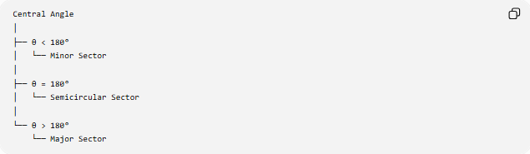
Central Angle
│
├── θ < 180°
│ └── Minor Sector
│
├── θ = 180°
│ └── Semicircular Sector
│
└── θ > 180°
└── Major Sector
A central angle also determines whether the corresponding arc is:
- Minor Arc → less than ${180}^{∘}$
- Semicircular Arc → exactly ${180}^{∘}$
- Major Arc → greater than ${180}^{∘}$

Central Angle and Sector
# Source: AI Source: Provided by: [Data Path: Persons Table -> ID Column: 1, Name_En Column: Motasem Essam] -> From: [ChatGPT] on [7/25/2026]
A sector is determined by two radii and their included central angle.
The area of a sector is:
$$\boxed{A=\frac{θ}{{360}^{∘}}πr^{2}}$$
where:
- $A$= sector area
- $r$= radius
- $θ$= central angle in degrees
For radians:
$$\boxed{A=\frac{1}{2}r^{2}θ}$$

Central Angle and Arc Length
# Source: AI Source: Provided by: [Data Path: Persons Table -> ID Column: 1, Name_En Column: Motasem Essam] -> From: [ChatGPT] on [7/25/2026]
The central angle determines the corresponding arc length.
For degrees:
$$\boxed{L=\frac{θ}{{360}^{∘}}\left(2πr\right)}$$
For radians:
$$\boxed{L=rθ}$$
Thus, increasing the central angle increases the corresponding arc length.

Central Angle and Inscribed Angle
# Source: AI Source: Provided by: [Data Path: Persons Table -> ID Column: 1, Name_En Column: Motasem Essam] -> From: [ChatGPT] on [7/25/2026]
A central angle and an inscribed angle can intercept the same arc.
The central angle is twice the inscribed angle:
$$\boxed{m\left(\text{Central Angle}\right)=2m\left(\text{Inscribed Angle}\right)}$$
or:
$$\boxed{m\left(\text{Inscribed Angle}\right)=\frac{1}{2}m\left(\text{Central Angle}\right)}$$
For example, if:
$$m\left(∠AOB\right)={100}^{∘}$$
then an inscribed angle intercepting the same arc measures:
$$\frac{{100}^{∘}}{2}={50}^{∘}$$

Central Angle and Diameter
# Source: AI Source: Provided by: [Data Path: Persons Table -> ID Column: 1, Name_En Column: Motasem Essam] -> From: [ChatGPT] on [7/25/2026]
When two radii form a straight line through the center, they form a diameter.
Therefore:
$$\boxed{θ={180}^{∘}}$$
This central angle corresponds to a semicircular arc.

Central Angle and Full Circle
# Source: AI Source: Provided by: [Data Path: Persons Table -> ID Column: 1, Name_En Column: Motasem Essam] -> From: [ChatGPT] on [7/25/2026]
A complete revolution around the center is:
$$\boxed{{360}^{∘}}$$
Therefore:
$$m\left(\text{entire circle}\right)={360}^{∘}$$
A full circle can also be expressed as:
$$2π\text{ radians}$$

Degrees and Radians
# Source: AI Source: Provided by: [Data Path: Persons Table -> ID Column: 1, Name_En Column: Motasem Essam] -> From: [ChatGPT] on [7/25/2026]
Central angles can be measured in degrees or radians.
The fundamental conversion is:
$$\boxed{{180}^{∘}=π\text{ radians}}$$
Therefore:
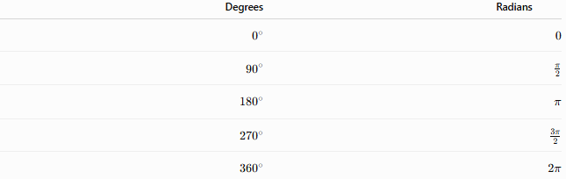
Degrees | Radians
$$0^{∘}$$ | $$0$$
$${90}^{∘}$$ | $$\frac{π}{2}$$
$${180}^{∘}$$ | $$π$$
$${270}^{∘}$$ | $$\frac{3π}{2}$$
$${360}^{∘}$$ | $$2π$$

Example
# Source: AI Source: Provided by: [Data Path: Persons Table -> ID Column: 1, Name_En Column: Motasem Essam] -> From: [ChatGPT] on [7/25/2026]
Suppose a circle has center $O$, and:
$$m\left(∠AOB\right)={60}^{∘}$$
Then the intercepted arc has measure:
$$m\left(\hat{AB}\right)={60}^{∘}$$
If the radius is $6$cm, the corresponding sector area is:
$$A=\frac{{60}^{∘}}{{360}^{∘}}π{\left(6\right)}^{2} \\ A=6π$$
Therefore:
$$\boxed{A=6π{\text{ cm}}^{2}}$$
The arc length is:
$$L=\frac{{60}^{∘}}{{360}^{∘}}\left(2π\right)\left(6\right) \\ \boxed{L=2π\text{ cm}}$$

Important Relationships
# Source: AI Source: Provided by: [Data Path: Persons Table -> ID Column: 1, Name_En Column: Motasem Essam] -> From: [ChatGPT] on [7/25/2026]
With the intercepted arc
$$\boxed{m\left(∠AOB\right)=m\left(\hat{AB}\right)}$$
With an inscribed angle
$$\boxed{m\left(∠AOB\right)=2m\left(∠ACB\right)}$$
when both intercept the same arc.
With a full circle
$$\boxed{\sum{\text{central angles}}={360}^{∘}}$$
for angles around the center that partition the circle.

Central Angle vs Inscribed Angle
# Source: AI Source: Provided by: [Data Path: Persons Table -> ID Column: 1, Name_En Column: Motasem Essam] -> From: [ChatGPT] on [7/25/2026]
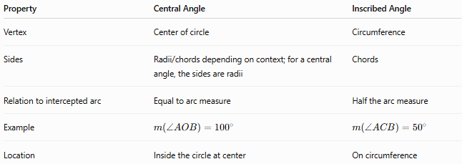
Property | Central Angle | Inscribed Angle
Vertex | Center of circle | Circumference
Sides | Radii/chords depending on context; for a central angle, the sides are radii | Chords
Relation to intercepted arc | Equal to arc measure | Half the arc measure
Example | $$m\left(∠AOB\right)={100}^{∘}$$ | $$m\left(∠ACB\right)={50}^{∘}$$
Location | Inside the circle at center | On circumference

Central Angle vs Sector
# Source: AI Source: Provided by: [Data Path: Persons Table -> ID Column: 1, Name_En Column: Motasem Essam] -> From: [ChatGPT] on [7/25/2026]
These are related but are not the same object.
- Central angle → an angular measurement formed by two radii.
- Sector → a region of the circle enclosed by two radii and an arc.
The central angle determines the size of the sector.

Key Points
# Source: AI Source: Provided by: [Data Path: Persons Table -> ID Column: 1, Name_En Column: Motasem Essam] -> From: [ChatGPT] on [7/25/2026]
- A central angle has its vertex at the center of a circle.
- Its sides are radii.
- Its measure equals the measure of its intercepted arc.
- Central angles range from $0^{∘}$to ${360}^{∘}$.
- A ${180}^{∘}$central angle produces a semicircle.
- A ${360}^{∘}$central angle represents a complete circle.
- Central angles are used to calculate arc lengths and sector areas.
- A central angle is twice an inscribed angle intercepting the same arc.

Conclusion
# Source: AI Source: Provided by: [Data Path: Persons Table -> ID Column: 1, Name_En Column: Motasem Essam] -> From: [ChatGPT] on [7/25/2026]
A Central Angle is one of the fundamental concepts in circle geometry. Because its vertex lies at the center, its measure directly equals the measure of the intercepted arc. Central angles provide the foundation for understanding arcs, sectors, circular segments, arc length, sector area, and the relationship between central and inscribed angles.

